DAY 2 OUTPUTS:

5] Logistic regression

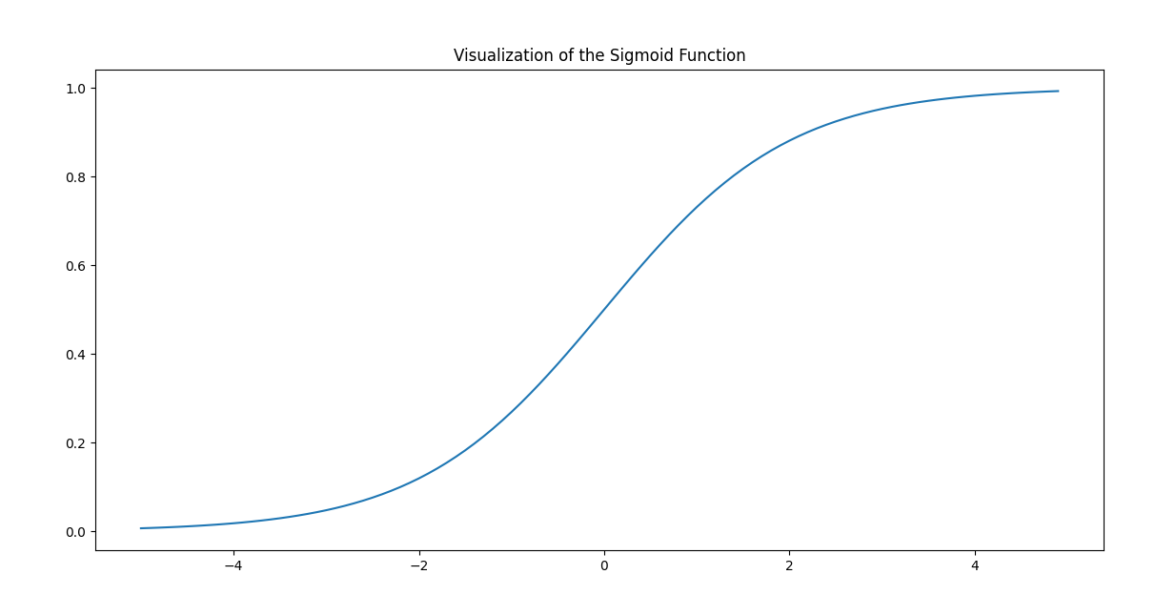

6a]KNN

[[10 0 0]

[ 0 9 0]

[ 0 0 11]]

1.0

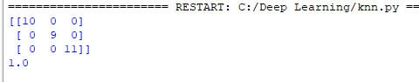

6b]Naïve bayes

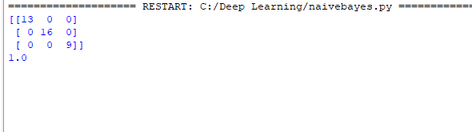

6c]Logistic regression accuracy

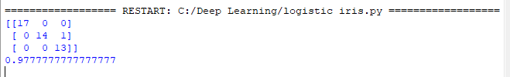

6d]Decision tree

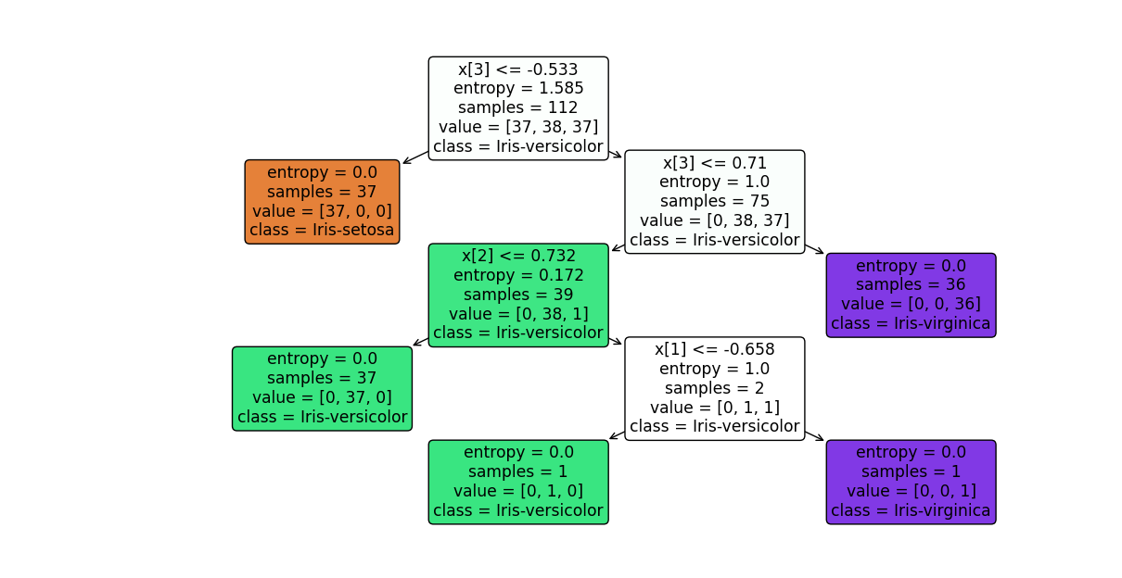

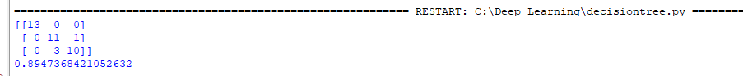

6e]Support Vector Machine

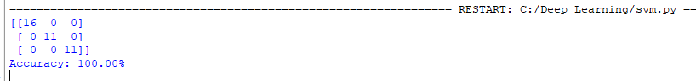

6f]Random forest

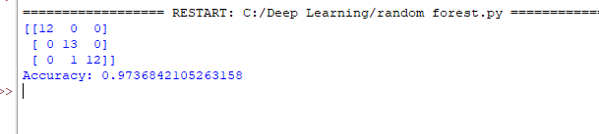

7A] Gradient descent

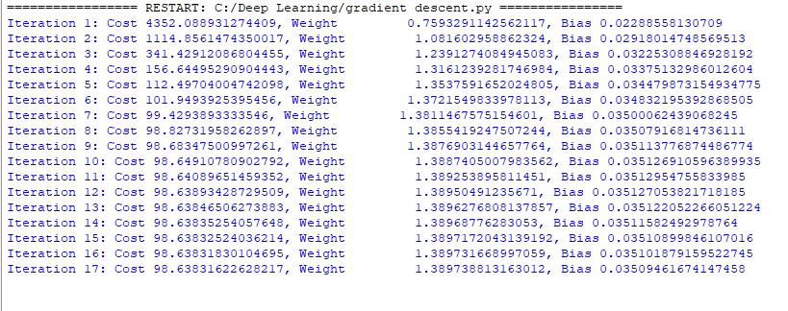

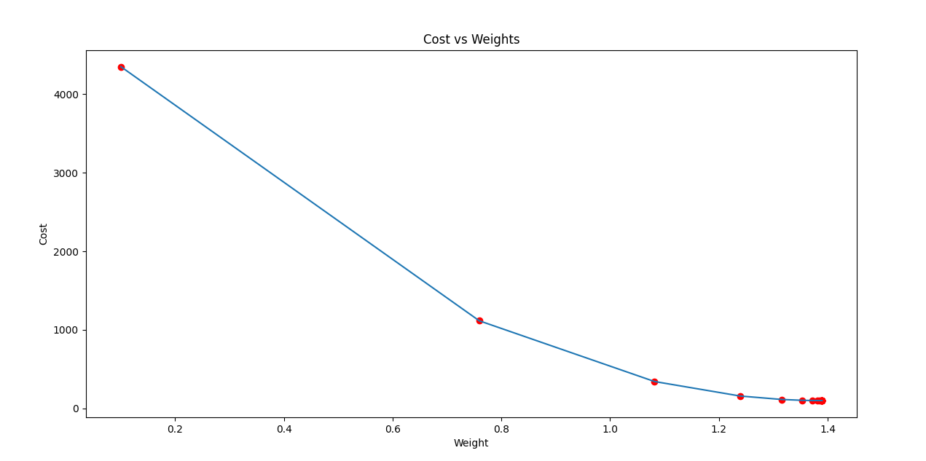

8a]Image processing



8b] Image processing using Watershed database

